**Python LAB Assignment - 4**

**Name: Vinay Santhosham**

**Class ID: 28**

**Team : 4**

**Tech Partner: Naga Sirisha Sunkara**

**Class ID:34**

**CNN**

Datasets:

1. Eco hotel data
2. Sentimental label data

1. Implement the text classification with CNN model, with a new dataset which is not used in the class

Hyper parameters:

Filter Size : 3,4,5

Optimizer : RMS Prop Optimizer

Number of Filters : 32

Dropout Probability : 0.25

Batch size : 64

Number of epochs : 100

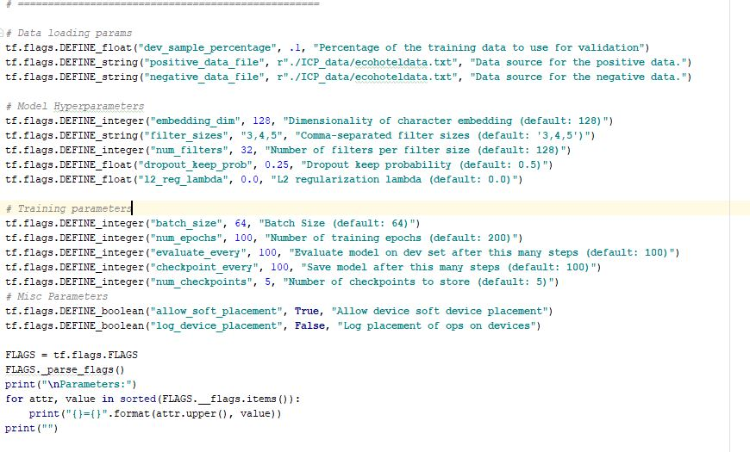

**Output:**

**2018-07-27T11:07:08.333553: step 300, loss 0.0975096, acc 0.941176**

Filter Size : 3,4,5

Optimizer : Adam Optimizer

Number of Filters : 32

Dropout Probability : 0.25

Batch size : 64

Number of epochs : 100



**Output:**

**2018-07-27T11:33:00.207615: step 300, loss 0.34742, acc 0.823529**

Filter Size : 3,4,5

Optimizer : Adagrad Optimizer

Number of Filters : 32

Dropout Probability : 0.25

Batch size : 64

Number of epochs : 100



**Output:**

**2018-07-27T11:36:44.425907: step 300, loss 0.541423, acc 0.764706**

Filter Size : 3,4,5

Optimizer : Gradient descent Optimizer

Number of Filters : 32

Dropout Probability : 0.25

Batch size : 64

Number of epochs : 100



**Output:**

**Evaluation:**

**2018-07-27T11:40:51.604835: step 300, loss 0.471642, acc 0.823529**

Filter Size : 1,2,3

Optimizer : Gradient descent Optimizer

Number of Filters : 64

Dropout Probability : 0.125

Batch size : 32

Number of epochs : 50

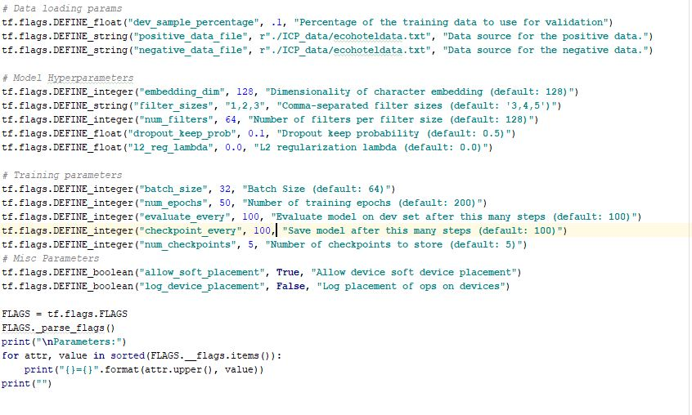

**Output:**

**Evaluation:**

**2018-07-27T11:44:25.826457: step 300, loss 0.555298, acc 0.705882**

Filter Size : 1,2,3

Optimizer : Adam Optimizer

Number of Filters : 64

Dropout Probability : 0.125

Batch size : 32

Number of epochs : 50



**Output:**

**Evaluation:**

**2018-07-27T11:47:46.011735: step 300, loss 0.179279, acc 0.882353**

Filter Size : 1,2,3

Optimizer : Adagrad Optimizer

Number of Filters : 64

Dropout Probability : 0.125

Batch size : 32

Number of epochs : 50



**Output:**

**Evaluation:**

**2018-07-27T11:50:11.530652: step 300, loss 0.782413, acc 0.529412**

Filter Size : 1,2,3

Optimizer : RMS Prop Optimizer

Number of Filters : 64

Dropout Probability : 0.125

Batch size : 32

Number of epochs : 50



**Output:**

**Evaluation:**

**2018-07-27T11:53:29.406375: step 300, loss 0.0986688, acc 1**

**Tensor Board Graph and Summaries:**

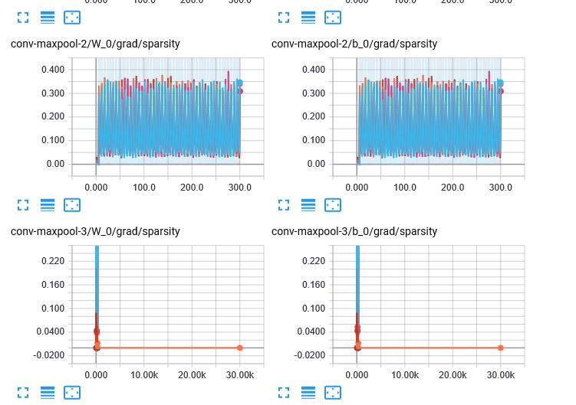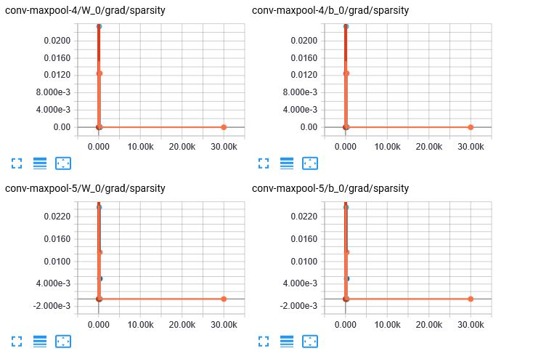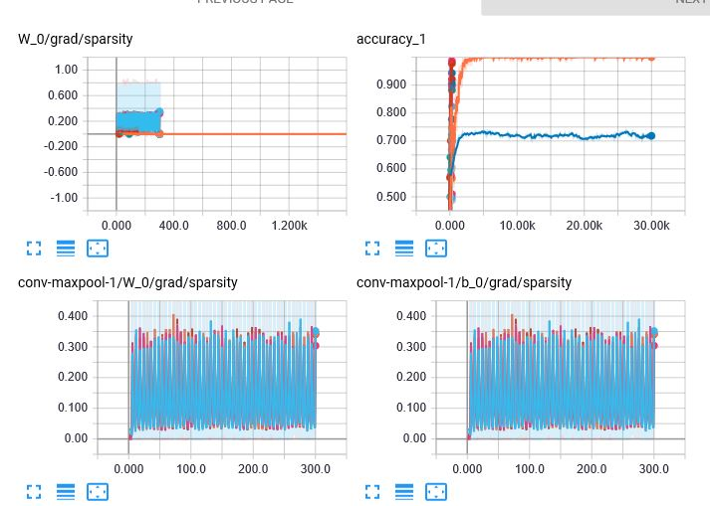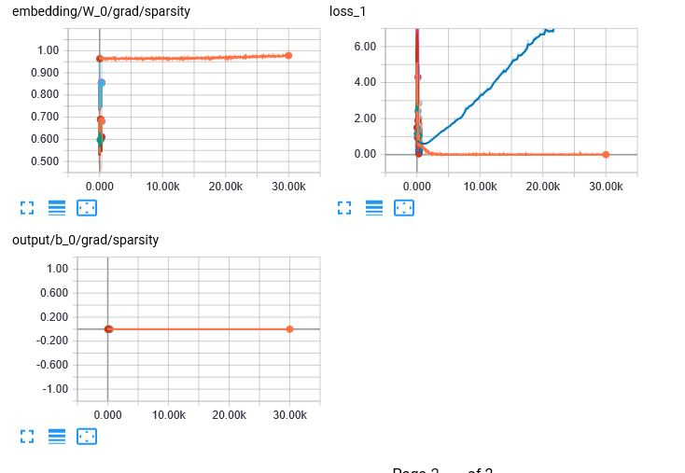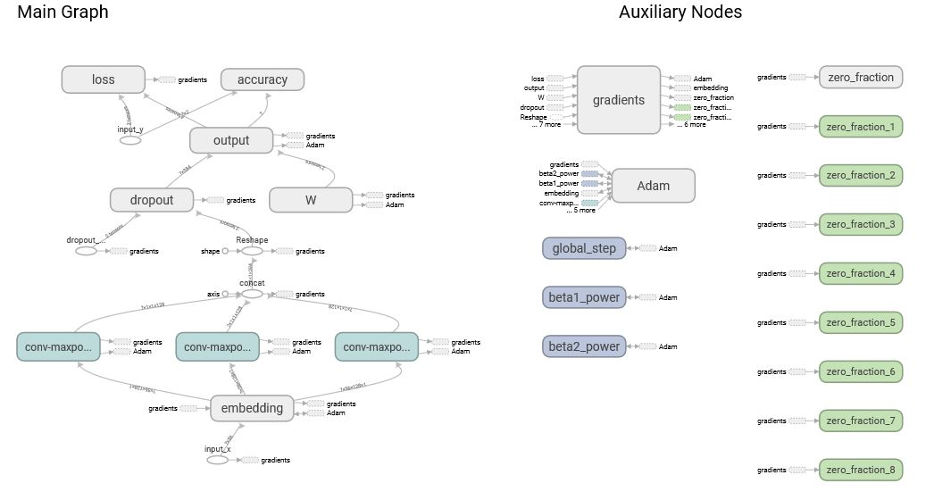

**RNN**

Datasets:

1. Eco hotel data
2. Sentimental label data

2. Implement the text classification with RNN/LSTM model, with a new dataset which is not used in the class

Hyper parameters:

Drop Out Probability : 0.25

Batch size: 64

Number of epochs: 100

Optimizer: RMS Prop Optimizer

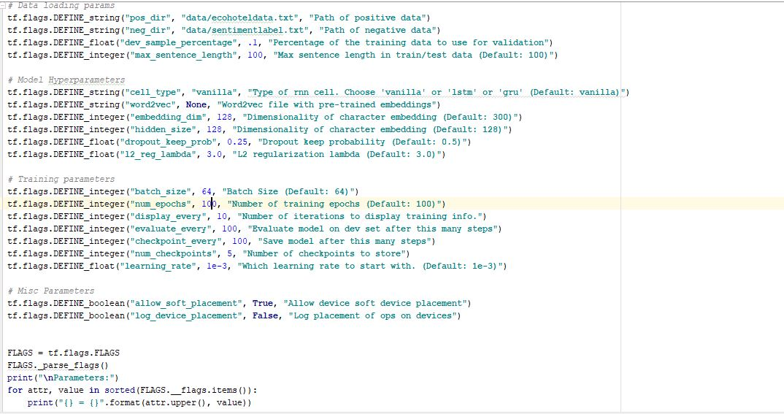

**Output:**

**Evaluation:**

**2018-07-27T19:50:37.805353: step 200, loss 0.37526, acc 0.909091**

Drop Out Probability : 0.25

Batch size: 64

Number of epochs: 100

Optimizer: Adam Optimizer



**Output:**

**Evaluation:**

**2018-07-27T19:51:58.919084: step 200, loss 0.561634, acc 0.909091**

Drop Out Probability : 0.25

Batch size: 64

Number of epochs: 100

Optimizer: Adagrad Optimizer



**Output:**

**Evaluation:**

**2018-07-27T19:52:14.095679: step 200, loss 4.38106, acc 0.727273**

Drop Out Probability : 0.25

Batch size: 64

Number of epochs: 100

Optimizer: Gradient descent Optimizer



**Output:**

**Evaluation:**

**2018-07-27T19:52:29.014433: step 200, loss 2.02515, acc 0.818182**

Drop Out Probability : 0.125

Batch size: 32

Number of epochs: 50

Optimizer: RMS Prop Optimizer

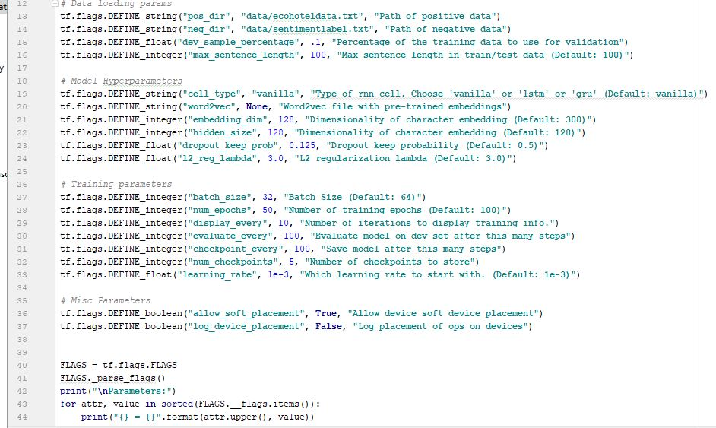

**Output:**

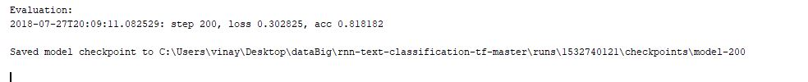

Drop Out Probability : 0.125

Batch size: 32

Number of epochs: 50

Optimizer: Adam Optimizer



**Output:**



Drop Out Probability : 0.125

Batch size: 32

Number of epochs: 50

Optimizer: Ada grad



**Output:**

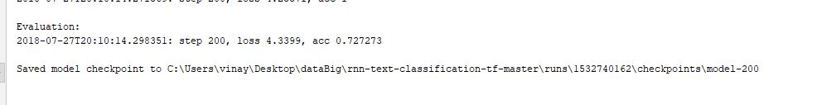

Drop Out Probability : 0.125

Batch size: 32

Number of epochs: 50

Optimizer: Gradient descent



**Output:**



Tensorboard scalar and graphs:

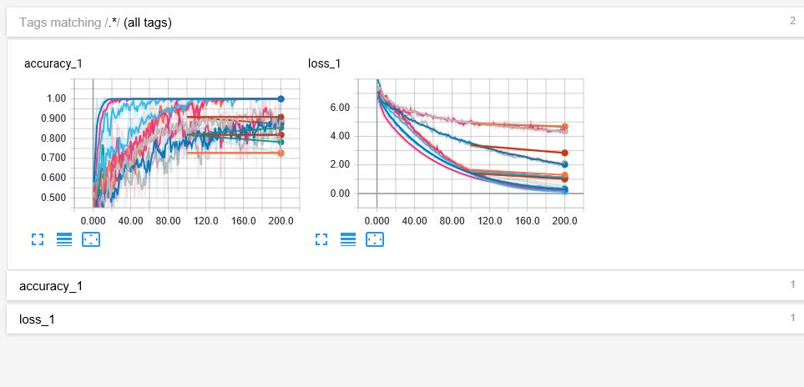

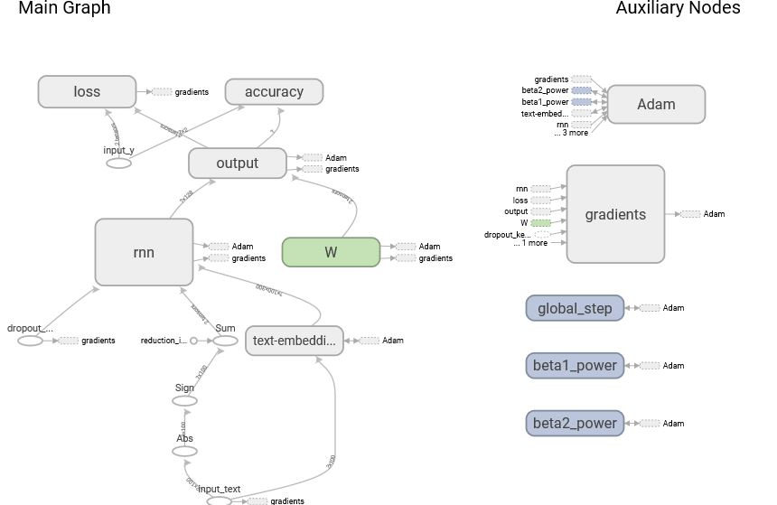

3. Compare the results of CNN and RNN/LSTM models, for the text classification (same dataset for 2 models to compare) and describe, which model is best for the text classification based on your results

**Datasets used:**

1. Eco hotel data
2. Sentimental label data

**CNN parameters:**

Filter Size : 3,4,5

Number of Filters : 32

Dropout Probability : 0.25

Batch size : 64

Number of epochs : 100

**RNN parameters:**

Drop Out Probability : 0.25

Batch size: 64

Number of epochs: 100

|  |  |  |
| --- | --- | --- |
| **Optimizer** | **CNN** | **RNN** |
| **RMS Prop** | **Output:**  **2018-07-27T11:07:08.333553: step 300, loss 0.0975096, acc 0.941176** | **Evaluation:**  **2018-07-27T19:50:37.805353: step 200, loss 0.37526, acc 0.909091** |
| **Adam** | **Output:**  **2018-07-27T11:33:00.207615: step 300, loss 0.34742, acc 0.823529** | **Evaluation:**  **2018-07-27T19:51:58.919084: step 200, loss 0.561634, acc 0.909091** |
| **Ada grad** | **Output:**  **2018-07-27T11:36:44.425907: step 300, loss 0.541423, acc 0.764706** | **Evaluation:**  **2018-07-27T19:52:14.095679: step 200, loss 4.38106, acc 0.727273** |
| **Gradient descent** | **Evaluation:**  **2018-07-27T11:40:51.604835: step 300, loss 0.471642, acc 0.823529** | **Evaluation:**  **2018-07-27T19:52:29.014433: step 200, loss 2.02515, acc 0.818182** |

**From the table above CNN model is best for text classification. In CNN, RMS Prop optimizer is best for text classification**.

4. Implement the image classification with CNN model, with a new dataset which is not used in the class

(E.g. CIFAR 10 dataset)

Code for CNN model:

Optimizer Used: RMS Prop

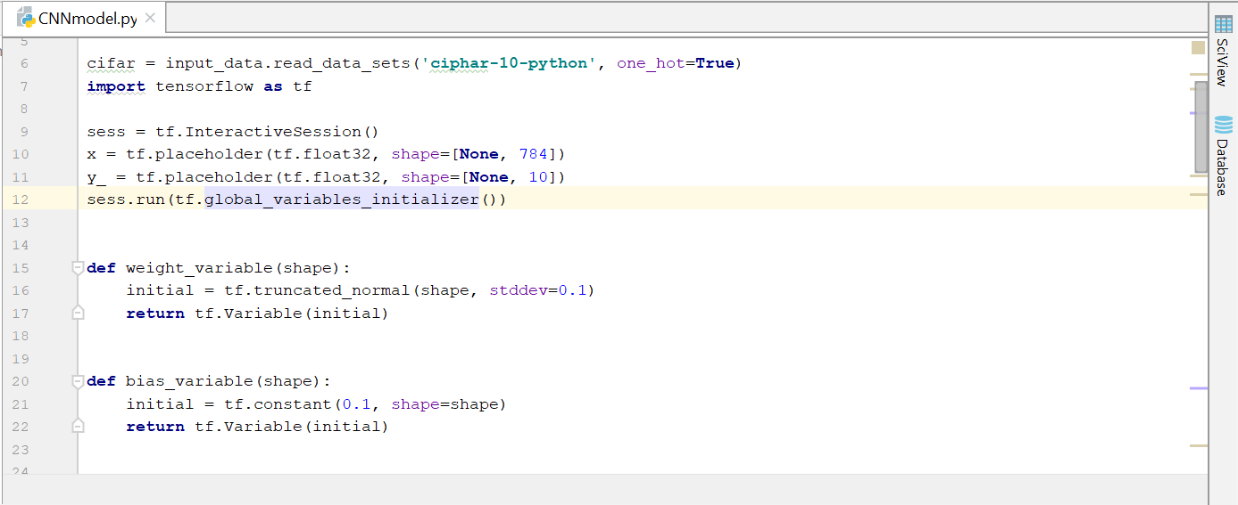

Output for CNN Model:

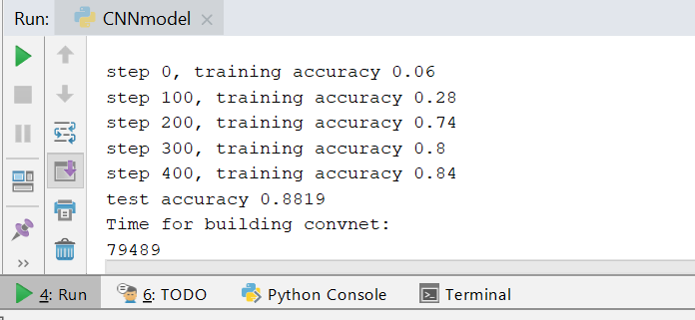

Ada grad optimizer

Output:

step 0, training accuracy 0.06

step 100, training accuracy 0.4

step 200, training accuracy 0.48

step 300, training accuracy 0.64

step 400, training accuracy 0.64

test accuracy 0.6137

Time for building convnet:

103051

Adam optimizer

step 0, training accuracy 0.22

step 100, training accuracy 0.8

step 200, training accuracy 0.82

step 300, training accuracy 0.84

step 400, training accuracy 0.76

test accuracy 0.8989

Time for building convnet:

95280

TensorBoard Graph:

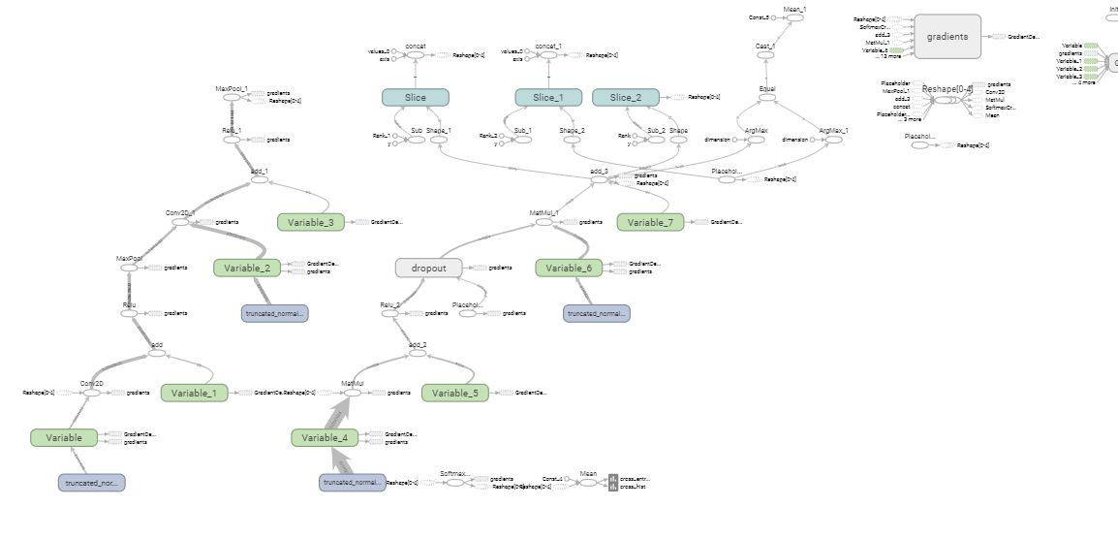

Youtube Links:

Part 1: <https://youtu.be/lceLXh3cTis>

Part 2: <https://youtu.be/YCA4Bx5PCSc>